

**IBM Team No:17**

**APPLIED DATA SCIENCE CAR RESALE VALUE PREDICTION**

**Team members: Mentor:**

Chidambaram KM Vimalraj V

Vengatesh VG

|  |
| --- |
| Harrish D  Mukesh Kumar R |

APPLIED DATA SCIENCE

CAR RESALE VALUE PREDICTION

LITERATURE SURVEY

**1.CAR PRICE PREDICTION :**

PUBLISHED IN : April 2022 by Journal of Emerging Technologies and Innovative Research (JETIR) India has a considerable size of car sales on top of the world day-today many buyers usually sell their cars after using for the time to another buyer, they name them as second possessor.Numerous platforms such as carwale.com, cartrade.com, cars24.com, OLX.com and cardekho.com etc. that come up with these buyers with a platform where they can sell their old cars, but what should be the price of the car, this is the long-lasting query ever by using Machine Learning algorithms and they lead a response to this issue. Using a history of previous used car sales data and machine learning methodologies like Supervised Learning, they used to predict a fair price for the car and they also used machine learning techniques like Random Forest and Extra Tree Regression, as well as the popular Python package ScikitLearn.

**2**.**USED CAR PRICE PREDICTION AND LIFE SPAN :**

PUBLISHED IN-December 2021 by International Advanced Research Journal in Science, Engineering and Technology-IARJSET. The main objective of this project is to predict the Prices of Used Cars,compare the prices and also estimate the lifespan of a particular car, keeping in mind various statistics of that car. The predictions are based on dataset collected from various websites and Kaggle Websites mostly. This project will compare all this data to all regression algorithms and performance of various machine learning algorithms such as Linear Regression, Ridge Regression, Decision tree Regressor and choose the best out of it. Depending on various parameters the project will determine the price of a car and compare the prices of old cars with new cars. The lifespan of the car can be determined using Government regulations and Company claims. Apart from various factors, they also consider GPS navigator to predict the price of the car.

**3.Car Price Prediction Using Machine Learning :**

PUBLISHED IN- June 2021 by International Journal of Innovative Research In Technology Project was developed by Ketan Agrahari, Ayush Chaubey, Mamoor Khan, Manas Srivastava Department of Computer Science and Engineering, Raj Kumar Goel Institute of Technology, AKTU. The used automobile market is a growing business with a market value that has nearly doubled itself in previous years. The rise of online websites and other tools like it have made it easier for both buyers and sellers to get a better understanding of the factors that determine the market value of a used car. Based on a set of factors, Machine Learning algorithms may be used to forecast the price of any automobile. The data set will include information on a variety of automobiles. There will be information regarding the vehicle's technical elements, such as the engine type,fuel type, the kilometers per liter, and more, for each car.The cost is calculated using the amount of characteristics. They used linear regression and lasso regression to develop a price model for used automobiles in a comparative research. Data was gathered from Kaggle for each algorithm. The main goal of this study is to discover the best predictive model for estimating the price of a used car.

**4.Used Car Price Prediction using K-Nearest Neighbor Based Model :**

PUBLISHED IN-September 2020 by International Journal of Innovative Research in Applied Sciences and Engineering (IJIRASE). Predicting the price of used cars is one of the significant and interesting areas of analysis. As an increased demand in the second-hand car market, the business for both buyers and sellers has increased. For reliable and accurate prediction it requires expert knowledge about the field because of the price of the cars dependent on many important factors. This paper proposed a supervised machine learning model using KNN (K Nearest Neighbour) regression algorithm to analyze the price of used cars. They trained their model with data of used cars which is collected from the Kaggle website. Through this experiment, the data was examined with different trained and test ratios. In this paper, we have trained our model with a used cars data set to predict the price. Here we have used the K nearest Neighbour algorithm and we got accuracy 85% where the accuracy of linear regression is 71%. The proposed model is also validated with 5 and 10 folds by using K Fold Method. The experimental analysis shows that the proposed model is fitted as the optimized model.

**5.Car Price Prediction using Machine Learning Techniques**

PUBLISHED IN - February 2019 by TEM Journal Project was developed by Enis Gegic, Becir Isakovic, Dino Keco, Zerina Masetic, Jasmin Kevric International Burch University, Sarajevo, Bosnia and Herzegovina Car price prediction can be a challenging task due to the high number of attributes that should be considered for the accurate prediction. The major step in the prediction process is collection and preprocessing of the data. In this research,PHP scripts were built to normalize, standardize and clean data to avoid unnecessary noise for machine learning algorithms. To build a model for predicting the price of used cars in Bosnia and Herzegovina, we applied three machine learning techniques (Artificial Neural Network, Support Vector Machine and Random Forest). However, the mentioned techniques were applied to work as an ensemble. The data used for the prediction was collected from the web portal autopijaca.ba using a web scraper that was written in PHP programming language. Respective performances of different algorithms were then compared to find one that best suits the available data set.

**PROJECT DESCRIPTION**

With difficult economic conditions, it is likely that sales of second hand imported (reconditioned) cars and used cars will increase. In many developed countries, it is common to lease a car rather than buying it outright. After the lease period is over, the buyer has the possibility to buy the car at its residual value, i.e. its expected resale value. Thus, it is of commercial interest to sellers/financers to be able to predict the salvage value (residual value) of cars with accuracy.

In order to predict the resale value of the car, we proposed an intelligent, flexible and effective system that is based on using regression algorithms. Considering the main factors which would affect the resale value of a vehicle a regression model is to be built that would give the nearest resale value of the vehicle. We will be using various regression algorithms and algorithms with the best accuracy will be taken as a solution, then it will be integrated to the web-based application where the user is notified with the status of his product.

**Technical Architecture:**

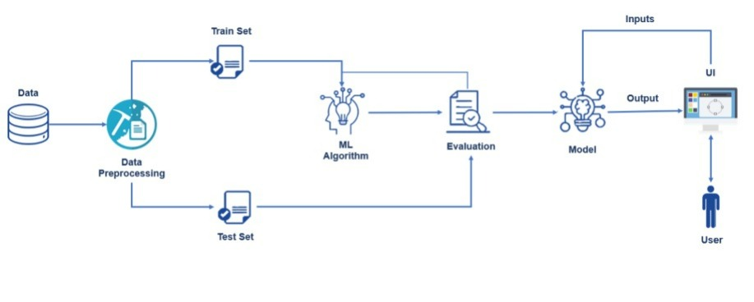

**SOLUTION:**

In modern India, the demand for second hand car has been increased rapidly. In that regard, our main motive of this project is to create a trustable and affordable web application for user to find second hand cars more effectively. The key concern of our project is to predict the accurate value of a car using machine learning techniques. The main predictor of prices depends on the number of Kilometers the car has been driven, brand of the car, engine condition, fuel type, etc.. In this project we use the k –nearest neighbouring algorithm to predict the value of the car. To predict the engine and car condition we use the neural networks and Convolutional Neural Networks(CNN) to predict the accurate value of the car.